Switching between Marketable Modules

Contents

Introduction 2

How to create a marketable module 3

Rating Scale Module 3

Edit Pages 3

Settings Pages 4

View Pages 7

Category Grouping Module 10

Edit Pages 10

Settings Pages 11

Multiple Choice 11

Edit Pages 11

Settings Pages 11

Sentence Completion 12

Edit Pages 12

Settings Pages 12

Open End 12

Edit Pages 12

Settings Pages 12

# Introduction

The Questionnaire module consists of one main module, all maintenance is done to this module.

A number of marketable modules are created from the one main module. Each of them differs from the main module only in that selected code has been uncommented.

This paper is a manual specifying in how to create each of the marketable modules by oncommenting code in the main module (Questionnaire module).

# How to create a marketable module

## Rating Scale Module

### Edit Pages

#### The following code must be uncommented in the ascx. File:

<asp:Menu ID="MenuQType" runat="server">

<Items>

<asp:MenuItem Text="Rating Scales" Value="Rating Scales"></asp:MenuItem>

<%--<asp:MenuItem Text="Multiple Choice" Value="Multiple Choice"></asp:MenuItem>

<asp:MenuItem Text="Open End" Value="Open End"></asp:MenuItem>

<asp:MenuItem Text="Check Box" Value="Check Box"></asp:MenuItem>

<asp:MenuItem Text="DropDown List" Value="DropDown List"></asp:MenuItem>--%>

<asp:MenuItem Text="Text" Value="Text"></asp:MenuItem>

</Items>

</asp:Menu>

For the non ajaxified version:

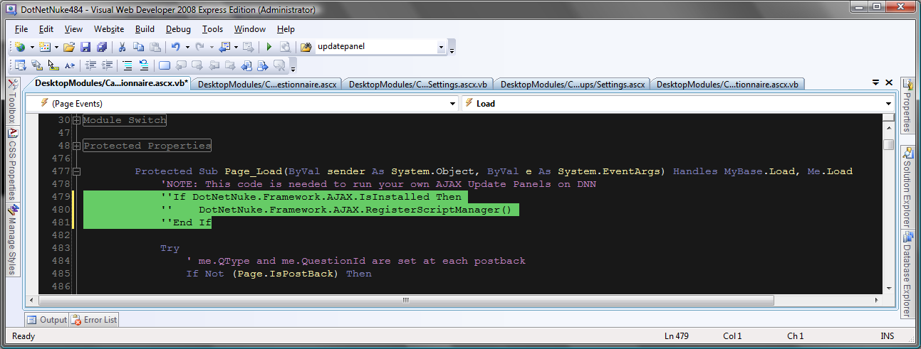

#### The following code must be uncommented in the code behind:

Protected Sub ddlCategory_Load(ByVal sender As Object, ByVal e As System.EventArgs)

' Setting the Category property and the ddlCategory dropdownlist

Try

If Me.QType = myEnums.EnumQType.RatingScales Then

'Switch: Me.ddlCategory.Visible = "True"

'Switch: Dim paCategory As Panel = DirectCast(FVRatingScales.FindControl("paCategory"), Panel)

'Switch: paCategory.Visible = "True"

Else

Me.ddlCategory.Visible = "False"

' prevents an error from occuring as the dropdownlist will otherwise not be able to match "Category" and "QCategory" in the ddlCategory dropdownlist

Me.ddlCategory.Items.Add("N/A")

Me.ddlCategory.SelectedValue = "N/A"

End If

Catch exc As Exception

Exceptions.ProcessModuleLoadException(Me, exc)

Throw New Exception("Error in ddlCategory_Load method")

End Try

End Sub

Protected Sub MenuQType_Click(ByVal sender As Object, ByVal e As System.Web.UI.WebControls.MenuEventArgs) Handles MenuQType.MenuItemClick

Select Case e.Item.Value

Case "Rating Scales"

Me.QType = myEnums.EnumQType.RatingScales

FVRatingScales.ChangeMode(FormViewMode.Insert)

MultiViewEditQuestionnaire.ActiveViewIndex = myEnums.EnumQType.RatingScales

'Me.ddlCategory.Visible = "True"

'Dim paCategory As Panel = DirectCast(FVRatingScales.FindControl("paCategory"), Panel)

'paCategory.Visible = "True"

'Case "Multiple Choice"

' Me.QType = myEnums.EnumQType.MultipleChoice

' FVMultipleChoice.ChangeMode(FormViewMode.Insert)

' MultiViewEditQuestionnaire.ActiveViewIndex = myEnums.EnumQType.MultipleChoice

'Case "Open End"

' Me.QType = myEnums.EnumQType.OpenEnd

' FVRatingScales.ChangeMode(FormViewMode.Insert)

' MultiViewEditQuestionnaire.ActiveViewIndex = myEnums.EnumQType.RatingScales

' paShowOpenEndTypes.Visible = True

'Case "Check Box"

' Me.QType = myEnums.EnumQType.CheckBox

' FVRatingScales.ChangeMode(FormViewMode.Insert)

' MultiViewEditQuestionnaire.ActiveViewIndex = myEnums.EnumQType.RatingScales

'Case "DropDown List"

' Me.QType = myEnums.EnumQType.DropDownList

' FVMultipleChoice.ChangeMode(FormViewMode.Insert)

' MultiViewEditQuestionnaire.ActiveViewIndex = myEnums.EnumQType.MultipleChoice

' Me.TBQuestion2MC.Visible = True

' Dim paQuestion2 As Panel = DirectCast(FVMultipleChoice.FindControl("paQuestion2"), Panel)

' paQuestion2.Visible = "True"

Case "Text"

Me.QType = myEnums.EnumQType.Text

FVRatingScales.ChangeMode(FormViewMode.Insert)

MultiViewEditQuestionnaire.ActiveViewIndex = myEnums.EnumQType.RatingScales

End Select

End Sub

For the non ajaxified version:

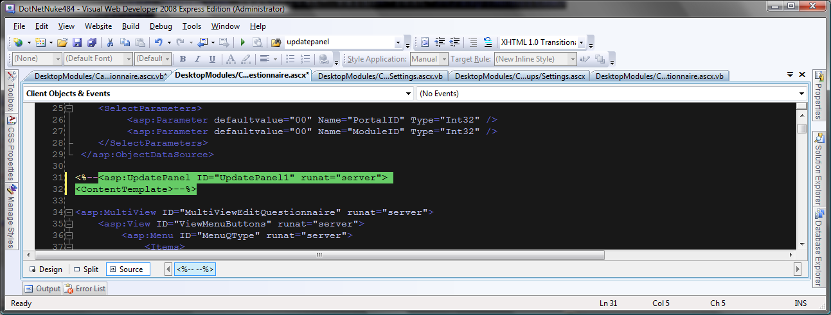

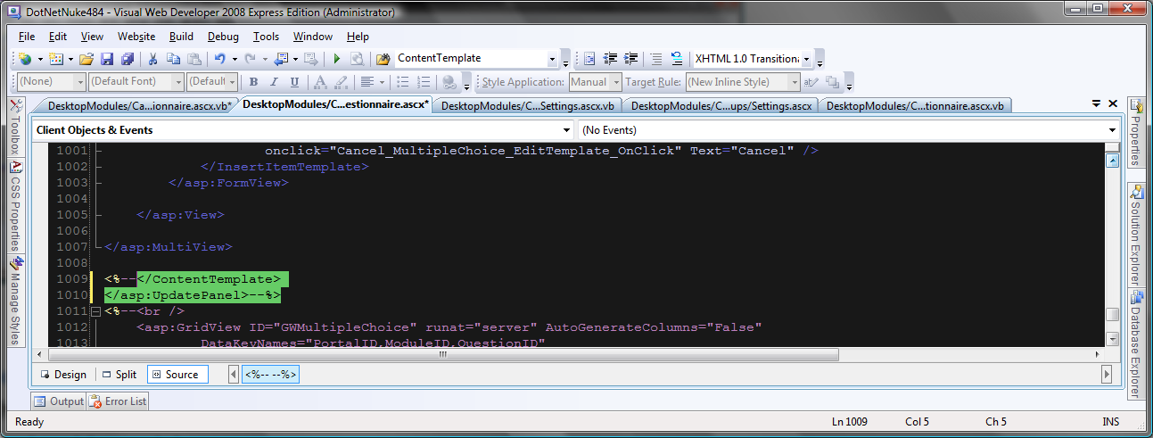

### Settings Pages

The procedures in the bottom of the Page_Load sub are commented/uncommented to show the different marketable modules.

See code below.

Protected Sub Page_Load(ByVal sender As Object, ByVal e As System.EventArgs) Handles Me.Load

If DotNetNuke.Framework.AJAX.IsInstalled Then

DotNetNuke.Framework.AJAX.RegisterScriptManager()

DotNetNuke.Framework.AJAX.RegisterPostBackControl(btnExport)

End If

'CategoryGrouping

'RatingScales()

MultipleChoice()

'SentenceCompletion

'OpenEnd

End Sub

And

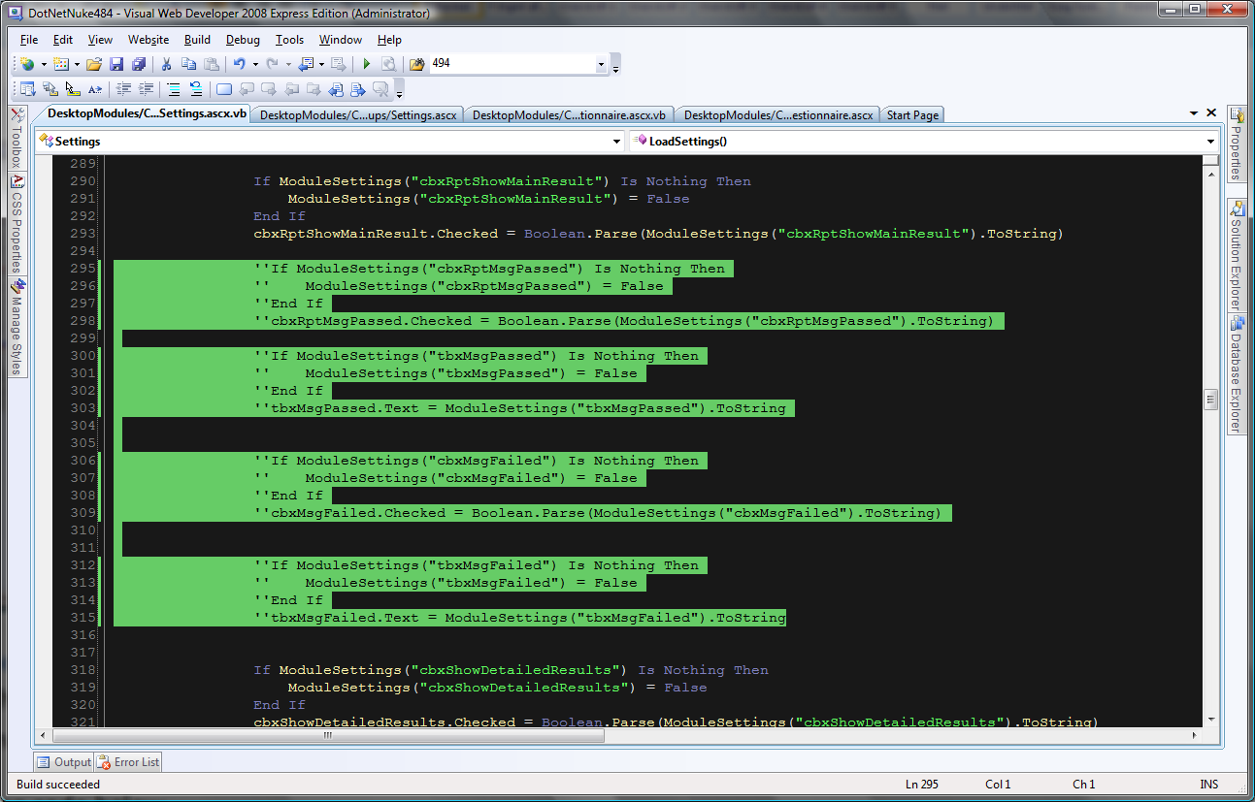

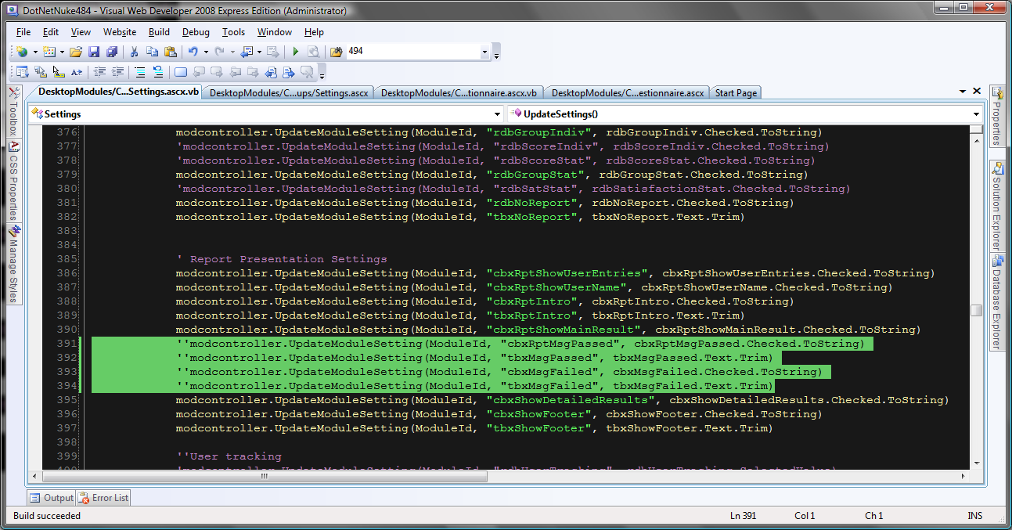

Further some reporting options must be uncommented as shown below:

<table>

<%--<tr>

<td width="150" class="style2">

</td>

<td colspan="2" class="style2">Individual</td>

<td colspan="2" class="style2">Statistical</td>

</tr>

<tr>

<td width="150">

<dnn:Label ID="lblOEReport" runat="server" controlname="lblOEReport"

suffix=":" />

</td>

<td>

<asp:Radiobutton ID="rdbOpenIndiv" runat="server" GroupName="grpRpt" />

</td>

<td>

<%--<asp:LinkButton ID="lbnOpenIndiv" runat="server">Show</asp:LinkButton>--%>

</td>

<td>

</td>

<td>

</td>

</tr>

<tr>

<td width="150">

<dnn:Label ID="lblRSReport" runat="server" controlname="lblRSReport"

suffix=":" />

</td>

<td>

<asp:Radiobutton ID="rdbGroupIndiv" runat="server" GroupName="grpRpt" />

</td>

<td>

<%--<asp:LinkButton ID="lbnGroupIndiv" runat="server">Show</asp:LinkButton>--%>

</td>

<td>

<asp:Radiobutton ID="rdbGroupStat" runat="server" GroupName="grpRpt" />

<asp:LinkButton ID="lbnGroupStat" runat="server">Show</asp:LinkButton>

</td>

<td>

</td>

</tr>

<tr>

<td width="150">

<dnn:Label ID="lblScoreReport" runat="server" controlname="lblScoreReport"

suffix=":" />

</td>

<td>

<asp:Radiobutton ID="rdbScoreIndiv" runat="server" GroupName="grpRpt" />

</td>

<td>

<%--<asp:LinkButton ID="lbnScoreIndiv" runat="server">Show</asp:LinkButton>--%>

</td>

<td>

<asp:Radiobutton ID="rdbScoreStat" runat="server" GroupName="grpRpt" />

<asp:LinkButton ID="lbnScoreStat" runat="server">Show</asp:LinkButton>

</td>

<td>

</td>

</tr>--%>

<tr>

<td width="150">

<dnn:Label ID="lblSatReport" runat="server" controlname="lblSatReport"

suffix=":" />

</td>

<td>

<asp:Radiobutton ID="rdbSatisfactionStat" runat="server" GroupName="grpRpt" />

<asp:LinkButton ID="lbnSatisfactionStat" runat="server">Show</asp:LinkButton>

</td>

<td>

&nbsp;</td>

<td>

&nbsp;

</td>

<td>

</td>

</tr>

<tr>

<td width="150">

<dnn:Label ID="lblNoReport" runat="server" controlname="lblSatReport"

suffix=":" />

</td>

<td>

<asp:Radiobutton ID="rdbNoReport" runat="server" GroupName="grpRpt" />

<asp:LinkButton ID="lbnNoReport" runat="server">Show</asp:LinkButton>

</td>

<td>

&nbsp;</td>

<td>

</td>

<td>

</td>

</tr>

<tr>

<td width="150">

<dnn:Label ID="lblLinkToPage" runat="server" controlname="lblSatReport"

suffix=":" />

</td>

<td colspan="4">

Link to:

<asp:TextBox ID="tbxNoReport" runat="server"></asp:TextBox>

</td>

</tr>

</table>

And the passed and failed options:

<%-- <tr>

<td width="150">

<dnn:Label ID="lblMsgPassed" runat="server" controlname="lblMsgPassed"

suffix=":" />

</td>

<td>

<asp:CheckBox ID="cbxRptMsgPassed" runat="server" />

</td>

<td>

<asp:TextBox ID="tbxMsgPassed" runat="server" Width="173px"></asp:TextBox></td></tr><tr>

<td width="150">

<dnn:Label ID="lblMsgFailed" runat="server" controlname="lblMsgFailed"

suffix=":" />

</td>

<td>

<asp:CheckBox ID="cbxMsgFailed" runat="server" />

</td>

<td>

<asp:TextBox ID="tbxMsgFailed" runat="server" Width="171px"></asp:TextBox></td></tr>--%>

And

<%--<cc1:MaskedEditExtender

ID="MaskedEditExtender2"

runat="server" Mask="$$$$$$$$$$$"

MessageValidatorTip="true"

TargetControlID="tbOpenEnd"

OnFocusCssClass="MaskedEditFocus"

OnInvalidCssClass="MaskedEditError" />--%>

<asp:TextBox ID="tbOpenEnd" runat="server" Visible="false"></asp:TextBox>

<%--<cc1:MaskedEditValidator

ValidationGroup="SubmitQ"

ID="MaskedEditValidator1"

runat="server"

ControlToValidate="tbOpenEnd"

ControlExtender="MaskedEditExtender2"

Display="Dynamic"

TooltipMessage='<%#Eval("Tooltip")%>'

IsValidEmpty="false"

EmptyValueMessage='<%#Eval("EmptyValue")%>'

InvalidValueMessage='<%#Eval("InvalidValue")%>'

OnFocusCssClass="MaskedEditFocus"

OnInvalidCssClass="MaskedEditError"

#### />--%>

#### In the code behind:

'If ModuleSettings("rdbOpenIndiv") Is Nothing Then

' ModuleSettings("rdbOpenIndiv") = False

'End If

'rdbOpenIndiv.Checked = Boolean.Parse(ModuleSettings("rdbOpenIndiv").ToString)

modcontroller.UpdateModuleSetting(ModuleId, "rdbOpenIndiv", rdbOpenIndiv.Checked.ToString)

'If ModuleSettings("rdbGroupIndiv") Is Nothing Then

' ModuleSettings("rdbGroupIndiv") = False

'End If

'rdbGroupIndiv.Checked = Boolean.Parse(ModuleSettings("rdbGroupIndiv").ToString)

'If ModuleSettings("rdbScoreIndiv") Is Nothing Then

' ModuleSettings("rdbScoreIndiv") = False

'End If

'rdbScoreIndiv.Checked = Boolean.Parse(ModuleSettings("rdbScoreIndiv").ToString)

'If ModuleSettings("rdbGroupStat") Is Nothing Then

' ModuleSettings("rdbGroupStat") = False

'End If

'rdbGroupStat.Checked = Boolean.Parse(ModuleSettings("rdbGroupStat").ToString)

'If ModuleSettings("rdbScoreStat") Is Nothing Then

' ModuleSettings("rdbScoreStat") = False

'End If

'rdbScoreStat.Checked = Boolean.Parse(ModuleSettings("rdbScoreStat").ToString)

'modcontroller.UpdateModuleSetting(ModuleId, "rdbGroupIndiv", rdbGroupIndiv.Checked.ToString)

'modcontroller.UpdateModuleSetting(ModuleId, "rdbScoreIndiv", rdbScoreIndiv.Checked.ToString)

'modcontroller.UpdateModuleSetting(ModuleId, "rdbScoreStat", rdbScoreStat.Checked.ToString)

'modcontroller.UpdateModuleSetting(ModuleId, "rdbGroupStat", rdbGroupStat.Checked.ToString)

'Protected Sub lbnGroupStat_Click(ByVal sender As Object, ByVal e As System.EventArgs) Handles lbnGroupStat.Click

' Response.Redirect(DotNetNuke.Common.Globals.NavigateURL(PortalSettings.ActiveTab.TabID, "Report", "mid=" & CStr(ModuleId), "action=2", "type=" & myEnums.Report.GroupingStatistical))

'End Sub

'Protected Sub lbnScoreStat_Click(ByVal sender As Object, ByVal e As System.EventArgs) Handles lbnScoreStat.Click

' Response.Redirect(DotNetNuke.Common.Globals.NavigateURL(PortalSettings.ActiveTab.TabID, "Report", "mid=" & CStr(ModuleId), "action=2", "type=" & myEnums.Report.ScoreStatistical))

'End Sub

### View Pages

#### Change names for validationgroups:

Validationgroups should be named differently between modules to prevent validationgroup collision:

Name as follows: SubmitRatingScales. Rule: (name: “Submit”+*module friendly name*)

#### The following code must be uncommented in the ascx. File:

<%--<style type="text/css">

.popupControl {

background-color:#AAD4FF;

position:absolute;

visibility:hidden;

border-style:solid;

border-color:red;

border-width: 2px;

}

.modalBackground

background-color:green;

filter:alpha(opacity=70);

opacity:1.00;

}

.modalpopup {

background-color:#ffffdd;

border-width:3px

border-style:solid;

border-color:black;

padding:3px;

width:250px;

}

/*MASKED EDIT RELATED STYLES*/

.MaskedEditFocus

{

background-color: #ffffcc;

color: #000000;

}

.MaskedEditMessage

{

color: #ff0000;

font-weight: bold;

}

.MaskedEditError

{

background-color: #ffcccc;

}

.MaskedEditFocusNegative

{

background-color: #ffffcc;

color: #000000;

}

.MaskedEditBlurNegative

{

color: #ff0000;

}

.MyCalendar .ajax__calendar_container {

border:1px solid #646464;

background-color: lemonchiffon;

color: black;

}

.MyCalendar .ajax__calendar_other .ajax__calendar_day,

.MyCalendar .ajax__calendar_other .ajax__calendar_year {

color: black;

}

.MyCalendar .ajax__calendar_hover .ajax__calendar_day,

.MyCalendar .ajax__calendar_hover .ajax__calendar_month,

.MyCalendar .ajax__calendar_hover .ajax__calendar_year {

color: black;

}

.MyCalendar .ajax__calendar_active .ajax__calendar_day,

.MyCalendar .ajax__calendar_active .ajax__calendar_month,

.MyCalendar .ajax__calendar_active .ajax__calendar_year {

color: black;

font-weight:bold;

}

.validatorCalloutHighlight

{

background-color: lemonchiffon;

}

</style>

<div>

<asp:Timer ID="TimerCountDown" runat="server" OnTick="TimerCountDown_Tick">

</asp:Timer>

</div>

<cc1:ModalPopupExtender ID="ModalPopupExtender1" runat="server" TargetControlID="LinkButton2" PopupControlID="paStartTimer" BackgroundCssClass="modalBackground" DropShadow="false">

</cc1:ModalPopupExtender>

<asp:Panel ID="paStartTimer" runat="server" CssClass="modalpopup" style="display:none" BorderColor="Black" BorderWidth="1" GroupingText="VanTane Questionnaire" Width="540" >

<table border="0" cellspacing="4" cellpadding="4" >

<tr>

<td align="left">

<asp:ImageButton ID="imgGo" runat="server" ImageUrl="../../images/icon_survey_32px.gif" Enabled="false" /></td>

<td align="right">

</td>

</tr>

<tr>

<td colspan="2">

<asp:TextBox ID="tbxTime" runat="server" Height="200px" ReadOnly="True"

Rows="100" TextMode="MultiLine" Width="500px" />

</td>

</tr>

<tr>

<td colspan="2" align="right">

<asp:Button ID="btnStartTest" runat="server" Text="OK" />

</td>

</tr>

</table>

</asp:Panel>

<cc1:ModalPopupExtender ID="ModalPopupExtenderLicensesAllowed" runat="server" OkControlID="btnOKLicenses" TargetControlID="LinkButton2" PopupControlID="paLicense" BackgroundCssClass="modalBackground" DropShadow="false">

</cc1:ModalPopupExtender>

<asp:Panel ID="paLicense" runat="server" CssClass="modalpopup" style="display:none" BorderColor="Black" BorderWidth="1" GroupingText="VanTane Questionnaire" Width="290" >

<table border="0" cellspacing="4" cellpadding="4" >

<tr>

<td align="left">

<asp:ImageButton ID="ImageButton1" runat="server" ImageUrl="../../images/yellow-warning.gif" Enabled="false" />

<asp:Label ID="Label12" runat="server" Text="WARNING" ForeColor="Red" Font-Size="Large"></asp:Label>

</td>

<td align="right">

</td>

</tr>

<tr>

<td colspan="2">

<asp:TextBox ID="TextBox1" runat="server" Height="200px" ReadOnly="True"

Rows="100" TextMode="MultiLine" Width="250px" >

The number of allowed user has been reached.

Please update this free product to the paid version in order to allow for more user entries.

</asp:TextBox>

</td>

</tr>

<tr>

<td colspan="2" align="right">

<asp:Button ID="btnOKLicenses" runat="server" Text="OK" />

</td>

</tr>

</table>

</asp:Panel>--%>

#### The following code must be uncommented in the code behind:

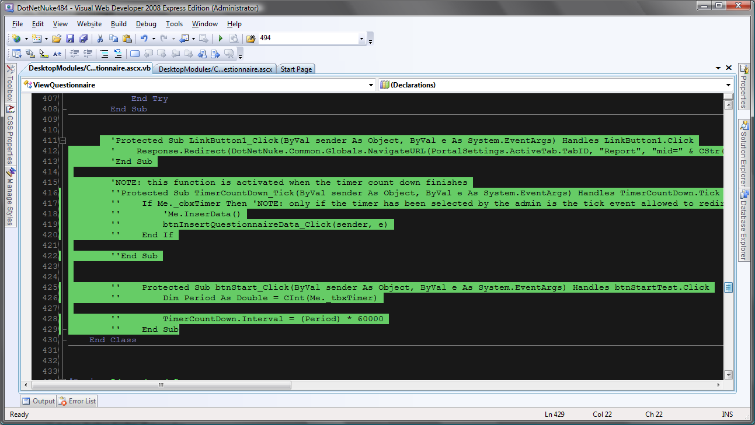

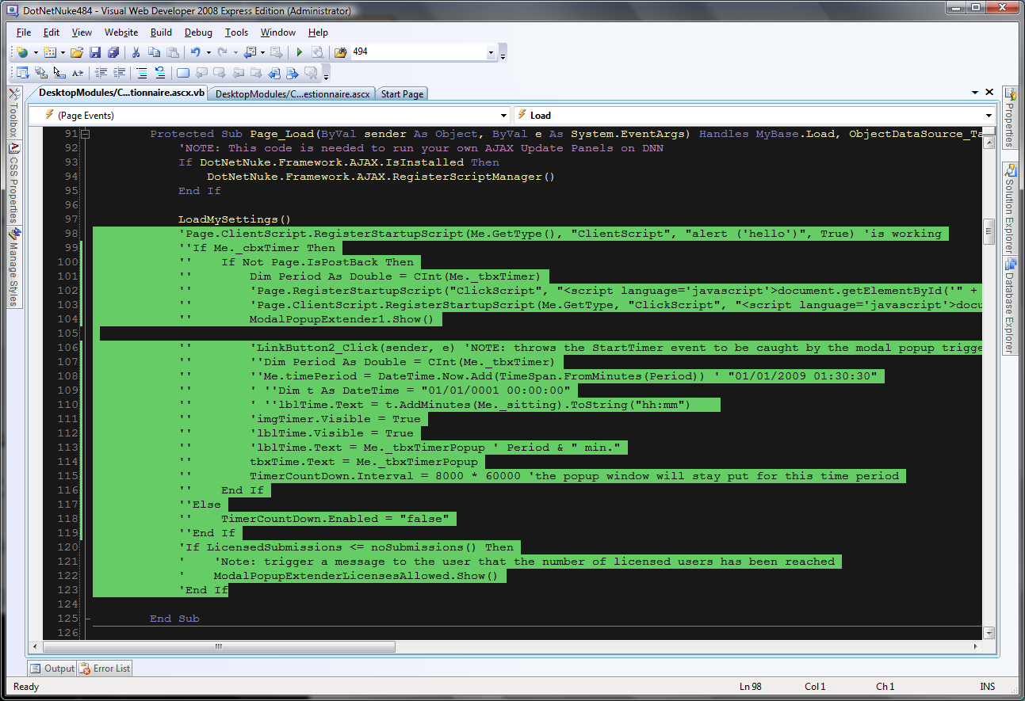

## Category Grouping Module

### Edit Pages

#### The following code must be uncommented in the ascx. File:

<asp:Menu ID="MenuQType" runat="server">

<Items>

<asp:MenuItem Text="Rating Scales" Value="Rating Scales"></asp:MenuItem>

<%--<asp:MenuItem Text="Multiple Choice" Value="Multiple Choice"></asp:MenuItem>

<asp:MenuItem Text="Open End" Value="Open End"></asp:MenuItem>

<asp:MenuItem Text="Check Box" Value="Check Box"></asp:MenuItem>

<asp:MenuItem Text="DropDown List" Value="DropDown List"></asp:MenuItem>--%>

<asp:MenuItem Text="Text" Value="Text"></asp:MenuItem>

</Items>

</asp:Menu>

#### The following code must be uncommented in the code behind:

Protected Sub MenuQType_Click(ByVal sender As Object, ByVal e As System.Web.UI.WebControls.MenuEventArgs) Handles MenuQType.MenuItemClick

Select Case e.Item.Value

Case "Rating Scales"

Me.QType = myEnums.EnumQType.RatingScales

FVRatingScales.ChangeMode(FormViewMode.Insert)

MultiViewEditQuestionnaire.ActiveViewIndex = myEnums.EnumQType.RatingScales

Me.ddlCategory.Visible = "True"

Dim paCategory As Panel = DirectCast(FVRatingScales.FindControl("paCategory"), Panel)

paCategory.Visible = "True"

'Case "Multiple Choice"

' Me.QType = myEnums.EnumQType.MultipleChoice

' FVMultipleChoice.ChangeMode(FormViewMode.Insert)

' MultiViewEditQuestionnaire.ActiveViewIndex = myEnums.EnumQType.MultipleChoice

'Case "Open End"

' Me.QType = myEnums.EnumQType.OpenEnd

' FVRatingScales.ChangeMode(FormViewMode.Insert)

' MultiViewEditQuestionnaire.ActiveViewIndex = myEnums.EnumQType.RatingScales

' paShowOpenEndTypes.Visible = True

'Case "Check Box"

' Me.QType = myEnums.EnumQType.CheckBox

' FVRatingScales.ChangeMode(FormViewMode.Insert)

' MultiViewEditQuestionnaire.ActiveViewIndex = myEnums.EnumQType.RatingScales

'Case "DropDown List"

' Me.QType = myEnums.EnumQType.DropDownList

' FVMultipleChoice.ChangeMode(FormViewMode.Insert)

' MultiViewEditQuestionnaire.ActiveViewIndex = myEnums.EnumQType.MultipleChoice

' Me.TBQuestion2MC.Visible = True

' Dim paQuestion2 As Panel = DirectCast(FVMultipleChoice.FindControl("paQuestion2"), Panel)

' paQuestion2.Visible = "True"

Case "Text"

Me.QType = myEnums.EnumQType.Text

FVRatingScales.ChangeMode(FormViewMode.Insert)

MultiViewEditQuestionnaire.ActiveViewIndex = myEnums.EnumQType.RatingScales

End Select

End Sub

### Settings Pages

The procedures in the bottom of the Page_Load sub are commented/uncommented to show the different marketable modules.

See code below.

## Multiple Choice

### Edit Pages

<asp:Menu ID="MenuQType" runat="server">

<Items>

<asp:MenuItem Text="Multiple Choice" Value="Multiple Choice"></asp:MenuItem>

<%--<asp:MenuItem Text="Rating Scales" Value="Rating Scales"></asp:MenuItem>

<asp:MenuItem Text="Open End" Value="Open End"></asp:MenuItem>

<asp:MenuItem Text="Check Box" Value="Check Box"></asp:MenuItem>

<asp:MenuItem Text="DropDown List" Value="DropDown List"></asp:MenuItem>--%>

<asp:MenuItem Text="Text" Value="Text"></asp:MenuItem>

</Items>

</asp:Menu>

#### The following code must be uncommented in the ascx. File:

#### The following code must be uncommented in the code behind:

### Settings Pages

The procedures in the bottom of the Page_Load sub are commented/uncommented to show the different marketable modules.

See code below.

## Sentence Completion

### Edit Pages

#### The following code must be uncommented in the ascx. File:

#### The following code must be uncommented in the code behind:

### Settings Pages

The procedures in the bottom of the Page_Load sub are commented/uncommented to show the different marketable modules.

See code below.

## Open End

### Edit Pages

#### The following code must be uncommented in the ascx. File:

#### The following code must be uncommented in the code behind:

### Settings Pages

The procedures in the bottom of the Page_Load sub are commented/uncommented to show the different marketable modules.

See code below.